Agenda

Jenkins, Jenkins Build file, Jenkins Installation

Agile Scrum

SonarQube, Sonar cloud & Sonar lint

Day 41 Revisit

DevOps = Development + Operations

Development = Analysing + Requirement Gathering + Planning + Coding + Testing

Operations = Configuring + Deploying + Maintaining

1. Security Enhancements
2. Introduce some new features
3. Remove very old/obsolete Technologies, in-secure features

End User needs

1. Very Fast
2. Rich UI (User Interface)
3. Highly Stable
4. Constantly updated applications
5. Very Secured.

Water Fall – Development Model (SDLC – Software Development Life Cycle)

Agile Scrum methodologies for Software Development

DevOps -  Is a set of practices and methodologies designed to combine the development (production/writing of code), deployment and maintenance of code into a streamlined or automated process.

DevOps Tools

1. Jenkins – Build Automation (Automatically build the code whenever some one commits changes to the code)
2. Docker (Containerization Tool) -
3. Sonar Qube / Sonar Lint/ Sonar Cloud – Code Quality Analysing Tool
4. Source Code Control (Github/ Gitlab/ Bit Bucket ….)
5. Building and Testing Automation ( Jenkins, Selenium, Cypress )
6. Deploying to Staging (Accessible by developers and company only not by public people)
7. Accessibility/Acceptance Testing
8. Final Build Deployment to production (Where end users can access it)

Environment

1. Development Environment
2. Testing Environment (Staging Environment)
3. Production Environment

**Continuous Integration (CI):** The process of regularly and consistently merging code into a central repository and reviewing new code to ensure that it integrates well within the previously established code base.

Integrating the newly added code with the existing code. (CI)

**CD – Continuous Delivery / Continuous Deployment**

**Continuous Delivery**

Development principle which focuses on the automation of the Dev Ops pipeline to the extent that human intervention is not required. Generally, this means that steps 1 - 3 (source code control, building and testing, and deployment to staging) are automated, while steps 4 (acceptance testing) may be handled by a Human, if necessary and step 5 (deployment to production environment) requires manual approval.

**Continuous Deployment**

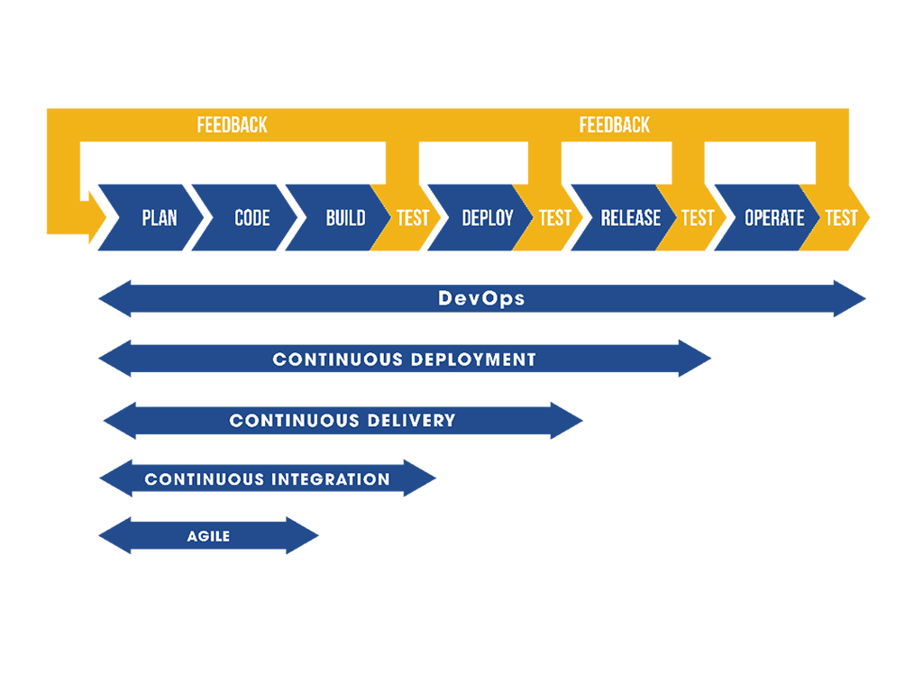

TDD – Test Driven Development

Continuous Deployment

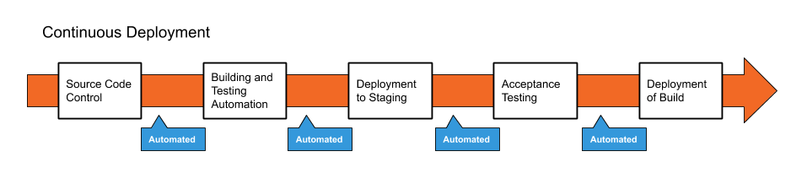

Continuous Delivery

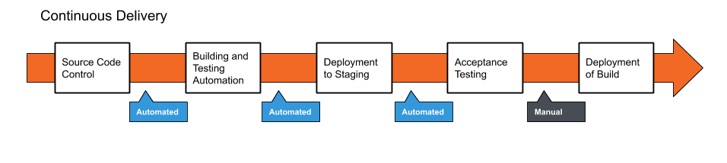

Jenkins – Build Automation Tool (Open Source Tool)

Official Site : <https://www.jenkins.io/>

Jenkins – Self-contained, open source automation server.

Jenkins automate the Build, Test & Deployment process.

Jenkins job is also called as Jenkins Build or Build pipeline or Build Job.

Download the Stable or LTS (Long Term Support) version

<https://www.jenkins.io/download/> -- Jenkins Download URL

jankins.msi (msi – Microsoft Installer) – Double click this file to install Jenkins in windows OS

Jenkins.war (self-contained war file that can be run on server manually)

Default port of Jenkins is 8080

When we run war file on tomcat, we can customize default Jenkins port number.

Jenkins Installer for Mac Users -- <https://www.jenkins.io/download/lts/macos/>

<https://www.jenkins.io/doc/tutorials/build-a-java-app-with-maven/> - Jenkins Maven

Jenkinsfile –

Is a text file where we add the build configuration details.

It will have many sections including the agent (how to run the build)

Sonar is one of the DevOps tool (Code Quality Analyser)

SonarQube (Stand -alone version)

Sonar Cloud (Cloud Tool)

Sonar Lint (Eclipse Plugin) – We can add with Eclipse IDE

Official Site : <https://www.sonarqube.org/> (Download Community Edition)

<https://docs.sonarqube.org/latest/setup/get-started-2-minutes/>

To use Sonar Qube (JDK11 is needed)

Open command prompt

Check java version “java -version”

Make sure it is pointing to jdk11 (change the env variable if necessary)

Open “startsonar.bat” file from sonarqube\bin folder

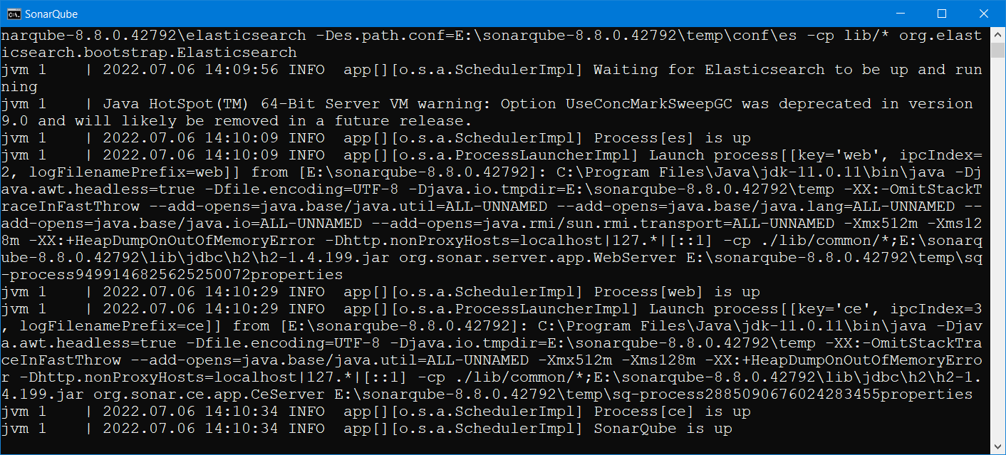

Once the “SonarQube is up” message is displayed in console

Open the browser, and go to localhost:9000 (9000 is the default port for SonarQube)

Default username and password is : admin